Organ Procurement

Introduction
Competent procurement of organs, both from cadaveric and living donors, is critical to the overall success of transplantation. This process includes not only the donor operation itself but also the evaluation of donors and potential recipients. Donors often have comorbid conditions, and not every organ is suitable for every recipient. Experience is probably the single most important factor for success. Organ procurement involves complex decision-making skills as well as a certain degree of technical expertise, particularly when multiple organs are to be utilized from a single donor. With the expansion of living donor options, judgment and skill are more vital than ever for achieving successful outcomes.
Many advances in organ donation have been made since the early 1990s. In particular, surgical techniques have been greatly refined. Not long ago, it was generally believed that a pancreas and a liver could not be procured for transplantation from the same donor. It is now even possible to take the heart, one or both lungs, the kidneys, the liver (whole or split), the pancreas, and the intestines from one donor and then to transplant them into as many as nine recipients at multiple transplant centers.^{[1]} Currently, procuring multiple organs from a single donor is the rule rather than the exception. In addition, nonvascularized tissues (e.g., bones, corneas, blood vessels, valves, and skin) can be harvested and used to help many more patients. These advances in technique notwithstanding, arguably the most important advance in modern transplantation is the widespread use of University of Wisconsin (UW) preservation solution, which has improved the safety of organ preservation and relaxed the time constraints on the transplantation of all organs.
As outcomes after transplantation improve, the demand for transplantable organs continues to far exceed the supply. As of spring 2002, more than 79,000 people in the United States were on waiting lists for kidney, pancreas, heart, liver, or intestinal transplantation.^{[2]} In response to this shortage, surgeons have sought to stretch the limits of the cadaveric donor pool by turning to extended-criteria donors. Use of older donors and donors with significant comorbidities (e.g., diabetes, hypertension, hepatitis B, hepatitis C, and steatosis) is now common.^{[3]} Many centers use hearts from 60-year-old donors^{[4]} and livers from donors in their 70s or even 80s,^{[5]} and some use organs from non-heart-beating donors.^{[6]} Kidneys from pediatric donors that previously would have gone unused now are often procured en bloc (i.e., together with a common patch of aorta and vena cava) for use in a single adult^{[7]}; some centers even transplant two older adult kidneys into a single adult recipient.^{[8]} Transplant surgeons now routinely split livers for use in multiple recipients. In some cases, organs from marginal donors (e.g., those who are receiving significant amounts of vasopressors or who experienced prolonged anoxia before resuscitation) are given as a last resort to patients who would die without an immediate transplant. Occasionally, certain organs from donors who had renal failure or were themselves transplant recipients may even be usable.
Although, to some extent, the use of extended-criteria cadaveric organ donors has helped offset the disparity between the available cadaveric donors and the ever-growing list of candidates for transplantation, this measure clearly falls far short of meeting the demand. If the donor pool is to be maintained and expanded, greater awareness on the part of potential donors is crucial. The public should be encouraged not only to sign the backs of driver's licenses or to enroll in their state's donor registry but also, more important, to discuss individual wishes for organ donation with families and loved ones.
Efforts to increase donor awareness, though important, have not sufficed by themselves. As transplant waiting lists grow longer, transplant programs have also begun to alleviate the organ shortage by applying living donor transplantation more broadly. Kidneys have been taken from living donors for many years; however, technological advances--in particular, laparoscopic donor nephrectomy--have now made living donation even more appealing. Since the early 1990s, segmental livers from living donors have been used with great success in pediatric recipients, and more recently, good results have been reported from transplantation of right or left lobes into adult recipients.^{[9]} A few centers have even performed pancreas, intestinal, and lung transplants from living donors.^{[10-12]} These procedures, though technically feasible, raise new ethical and philosophical issues and dilemmas.
In what follows, we outline the current state of organ procurement. With xenotransplantation still experimental and fraught with complex infectious and immunologic problems, procurement from cadaveric and live donors remains the cornerstone of transplantation at present. Cadaveric and live organ donors are discussed separately because donor evaluation, perioperative management, and the donor procedures themselves differ dramatically between the two groups.
Organ Procurement from Cadaveric Donors

Potential Cadaveric Donors
A patient does not become a potential organ donor until all attempts to save his or her life have failed. When a patient presents with a severe neurologic insult, all efforts should be directed at minimizing cerebral swelling and preventing brain herniation. This is often best accomplished by fluid restriction, hyperventilation, administration of diuretics as BP permits, and other therapies aimed at limiting cerebral edema. With advances in trauma management [see III:2 Injuries to the Central Nervous System] and critical care, more patients survive their initial insults.
A neurologist, a neurosurgeon, or both should be involved in the management of any patient who has incurred a severe neurologic insult. Such consultation is important for any eventual diagnosis of brain death, which can be made on clinical criteria alone but is often confirmed by means of electroencephalography (EEG), cerebral blood flow scanning, cerebral angiography, or some combination thereof. Irreversible coma as a criterion for death was defined by the Harvard criteria in 1968^{[13]} and then refined by the Uniform Determination of Death Act in 1981.^{[14]} The determination of death must include irreversible cessation of cardiopulmonary functions, neurologic functions, or both. Brain-dead patients have fixed, dilated pupils and lack protective corneal reflexes. Spinal reflexes, which do not involve the higher centers of the brain or the brain stem, may still be present. Spontaneous movements, known as Lazarus signs, occasionally occur as a consequence of primitive spinal reflex arcs. Donor surgeons should confirm that the clinical criteria of brain death have been documented appropriately. Individual hospitals and states may have different criteria for the declaration of brain death. Coma and brain death are discussed more fully elsewhere [see I:9 Coma, Seizures, Cognitive Impairment, and Brain Death].
In 1998, the Department of Health and Human Services issued a rule that requires hospitals that participate in Medicare to report all hospital deaths and imminent deaths to their local organ procurement organization (OPO) in a timely manner.^{[15]} The OPO then evaluates the patient's potential for organ donation, assists in the administrative details necessary for the declaration of death, and acts as intermediary between the hospital (including the nurses and physicians) and the donor's family.
In general, health care workers involved in the care of the patient should not approach the family regarding donation, so as to avoid even the insinuation of complicity in the donation process. Thus, the medical care of the patient is kept separate from the process of organ donation. Furthermore, success at obtaining consent for donation from next-of-kin is considerably more likely when the person requesting consent has undergone specialized training.^{[16]}
Once brain death has been declared and the decision has been made to proceed with organ donation, management of the donor is redirected toward optimizing potentially salvageable organs, a process that often necessitates aggressive fluid resuscitation.
It is imperative for health care providers to remember that whereas donors are not salvageable, dying patients are waiting for transplants, and their lives depend on the quality of the donated organs. Good donor management with careful attention to details (e.g., sterile technique, antibiosis, timely transfusion, and vasopressor management) is vital for achieving optimal outcomes from transplantation. In addition, it is important to demonstrate to health care workers, lay people, and donor families that donors are treated with respect and dignity. To transplant recipients and their medical caregivers, donors and their families are heroes.
Non-Heart-Beating Donors. The use of non-heart-beating donors is a relatively new concept in organ procurement. Historically, cadaveric organ donors were patients who had suffered an irreversible neurologic insult (e.g., head trauma, stroke, drug overdoses, or asphyxiation) and were declared brain-dead on life support. There are, however, many patients who do not meet the criteria for brain death but nevertheless have irreversible injuries. Faced with the severe shortage of organs for transplantation, many centers have established protocols by which such patients can be organ donors if their families consent. In the case of a "controlled" non-heart-beating donor, the patient is hospitalized and on life support. Cannulas are placed, usually in the femoral vessels (so that the organs can be quickly flushed in situ with cold UW solution after death), life support is discontinued, the heart is allowed to stop, and the patient dies. In the case of an "uncontrolled" non-heart-beating donor, cardiac arrest has occurred before the cannulas are placed.^{[6]}

Coordination of Donor and Recipient Activities
After a potential donor has been identified, the donor coordinator from the local OPO obtains a detailed medical and social history. Potential organ recipients are categorized according to (1) ABO blood group, (2) degree of medical urgency, (3) length of time the patient has been on the transplant list (i.e., waiting time), (4) weight, (5) acceptable weight range of the donor, and (6) distance the recipient team is willing to travel for procurement. The donor's acute physiologic status is assessed on the basis of BP (an arterial line is placed if not already present), central venous pressure (CVP), urine output, arterial blood gas values, and blood chemistry. Serologic analysis must be done for syphilis (Venereal Disease Research Laboratory [VDRL]), hepatitis B surface antigen (HBsAg), hepatitis B core antibody (HBcAb), hepatitis C virus (HCV), cytomegalovirus (CMV), human immunodeficiency virus (HIV), and human T cell lymphotropic virus type I (HTLV-1). In certain cases (e.g., kidney, pancreas, and intestinal transplants), inguinal lymph nodes must be removed through a small groin incision at the bedside to facilitate tissue typing, which takes an average of 4 hours. For kidneys in particular, genetic matching of donor and recipient has been shown to improve outcome.^{[17]}
After the potential organ donor has been studied and stabilized, the OPO coordinator contacts local and regional transplant programs about their needs for renal and extrarenal organs. The United Network for Organ Sharing (UNOS) maintains a national computer registry of potential recipients for all organs http://www.unos.org).
Sharing of all organs is based on the principle that organs should be offered first to patients in the local area and then to patients within a larger geographic region. (The United States has been divided by UNOS into 11 geographic regions for distribution of organs.) If no suitable recipient can be found locally or within the UNOS region, the organ is offered to patients across the nation. An exception to this rule exists for kidneys. For kidneys, when there is a six-antigen match (i.e., a perfect histocompatibility match between a donor and a recipient on all six HLA-A, HLA-B, and HLA-DR antigens) or when there is at least phenotypic identity between a donor and a prospective recipient (i.e., no HLA mismatch), the kidney must be offered to the matched recipient regardless of geographic location.
Specific medical criteria for prioritizing patients on the waiting lists for various organs are described elsewhere.^{[2]} The system for distributing livers changed in spring 2002 from one that gave significant weight to waiting time to one that stratified patients according to medical urgency.^{[18]} This new system has dramatically changed the way in which cadaveric livers are allocated and will undoubtedly have significant implications.
Once organs are matched to specific recipients, the local OPO procurement coordinator arranges an OR time for the donor procedure and organizes the arrivals of the participating surgical teams. Multiple-organ harvests require considerable coordination between the different institutions, surgeons, and coordinators. In the meantime, it is important that the donor be kept hemodynamically stable [see Cadaveric Donor Operation, below]. With the proliferation of experienced transplant centers, it has become common for most organs to be procured by local procurement teams and shipped to the recipient institutions. This collaboration has improved the coordination of the retrieval process, reduced the transportation costs associated with long-distance procurements, and helped ease the burden on the recipient teams. Certain organs, such as hearts, intestines, and multivisceral grafts, are still generally procured by the recipient institution.

Evaluation of Donor Organs
Donors are initially evaluated by the recipient surgeon on the basis of verbal reports of laboratory results and recent medical histories; however, the decision whether to use an organ ultimately depends on an experienced transplant surgeon's evaluation of the organ during the procurement procedure and on his or her knowledge of the potential recipient's medical status. Donor selection criteria vary for each organ and often vary by transplant center as well. Once-traditional limits are no longer absolute.
Liver. For livers, the results of liver function tests, including serum aspartate aminotransferase (AST), serum alanine aminotransferase (ALT), and bilirubin levels, should ideally be within normal ranges. Sometimes, depending on the donor's cause of death and degree of anoxia, test results are abnormal but improve with good resuscitation, in which case the liver may still be usable for transplantation. A history of hepatitis or alcoholism is a warning sign but not necessarily a contraindication to liver donation. Morbid obesity can pose problems for liver recovery: there is a high likelihood of macrovesicular steatosis, which increases the risk of primary nonfunction of the liver in the recipient. Microvesicular steatosis, on the other hand, is often the result of acute injury and is reversible; even significant degrees of microvesicular steatosis are generally not problematic.^{[19]} A percutaneous liver biopsy performed at the bedside may help prevent unnecessary donor laparotomies.
The relative sizes of the donor and the recipient must be taken into account. Advanced surgical techniques allow the liver to be split along anatomic divisions [see V:31 Hepatic Resection] so that portions of a single organ can be used in multiple recipients or so that the liver can be cut down to fit into a smaller recipient. Size is a particular concern in pediatric liver transplantation. Because small baby donor organs are relatively scarce, most pediatric centers obtain appropriately sized livers for their patients by performing right hepatic lobectomies or trisegmentectomies on adult cadaver organs and implanting the left lobe or the left lateral segment, depending on the size-matching between donor and recipient. In most cases, the remaining portion of the liver should be used in another recipient.
Kidneys. Several clinical factors and laboratory test results may be useful for the evaluation of potential kidney donors. As with all transplantable organs, a prolonged donor down time with a significant degree of anoxia is undesirable. A history of diabetes, hypertension, or both in the donor may preclude the use of the kidneys for transplantation. The serum creatinine concentration and (perhaps more important) the creatinine clearance are vital markers of kidney function. Certain comorbid conditions (e.g., hypercholesterolemia and obesity) are less important determinants of utility with kidneys than they are with livers. Kidney biopsies can be very helpful and are frequently performed, particularly in older donors.
Heart and Lung. The criteria for heart and lung donors are generally more strict than those for liver and kidney donors. Donors are usually younger, with no history of cardiac disease and a reasonably normal chest x-ray and electrocardiogram (ECG). They are closely matched to recipients with respect to height, weight, and chest circumference. Echocardiography is useful for evaluating cardiac wall motion and can play a key role in the decision whether to use the heart for transplantation. For certain potential donors, coronary angiography is necessary. In general, the donor's heart should be slightly larger than the recipient's, because recipients often have cardiomegaly. The arterial oxygen tension (P_{a}O₂) of lung donors should be at least 350 mm Hg during ventilation, with a fraction of inspired oxygen (F_{I}O₂) of 1. In addition, bronchoscopy is frequently useful in evaluation of lungs for donation.
Pancreas. Pancreas donors are generally younger than kidney or liver donors. Because pancreas transplantation, like kidney transplantation, is not lifesaving, pancreas donors tend to be chosen more discriminatingly. Clearly, diabetes is an absolute contraindication to donation. Alcohol use and obesity are relative contraindications. Laboratory tests for amylase and lipase may be useful. The gross appearance of the pancreas in the donor is extremely important in determining its suitability for transplantation. In view of the increasing success of islet cell isolation techniques, pancreata that are not used for whole organ transplantation should be used for islet cell transplantation or research.^{[20]}
Intestine. Intestinal transplantation has been approved by the Health Care Financing Administration (HCFA) and is no longer considered experimental.^{[21]} Like pancreas and kidney transplantation, however, intestinal transplantation is not considered lifesaving (because patients can be supported with parenteral nutrition). Accordingly, intestinal donors are chosen very selectively. The intestine is very sensitive to insult, particularly from hypotension; furthermore, many agents commonly used to support hypotensive donors cause mesenteric vasoconstriction, thereby limiting blood flow to the intestines. Size matching is extremely important in intestinal transplantation: results are very poor when the graft is too large and the abdomen cannot be closed primarily. Ideally, the donor should be 60% to 70% of the recipient's size. Because ischemia times must be kept short, HLA matching is rarely possible in this setting, and any potential benefit remains theoretical. Nevertheless, the crossmatch should be negative, particularly in isolated intestinal transplant cases. In addition, as in heart transplantation, it is often necessary to begin the recipient operation before the donor operation is completed so as to minimize ischemia times.

Perioperative Management
Regardless of which organs are to be procured, the donor must be maintained in a stable physiologic state during the evaluation. Basic monitoring should include an arterial line for BP monitoring and blood gas surveillance, a central venous line for CVP monitoring, and an indwelling urinary catheter for measuring urine output. Because the basic physiologic situation rarely, if ever, improves in brain-dead patients, the interval between the pronouncement of death and the donor procedure should be kept as short as possible. Unstable donors should be managed aggressively, with treatment directed at maintaining adequate circulation, ventilation, and diuresis. Donors are often dehydrated from earlier efforts to prevent or reduce cerebral edema, in which case rapid repletion of intravascular volume is required. Not infrequently, donors require blood transfusions.
Brain death is often associated with severe neurogenic shock and peripheral vasodilation. As a result, peripheral vascular resistance is often insufficient to support a normal BP, regardless of how well volume-loaded the patient may be. In such cases, vasopressor support is required. Because many vasopressors produce severe visceral, renal, or mesenteric vasoconstriction, they should be used judiciously so as not to injure the transplantable organs. With severe brain trauma or anoxia, pituitary function often fails. The resulting absence of antidiuretic hormone (ADH) causes diabetes insipidus, and a large-volume diuresis ensues, which can lead to severe volume depletion and donor instability. Initial therapy for diabetes insipidus includes intravenous replacement of urine output with 0.5 N saline. Hypernatremia may develop (sometimes quite rapidly); electrolyte levels should be monitored frequently. If fluid replacement cannot keep up with the diuresis, I.V. vasopressin may be given.
Before the donor is brought to the OR, the procurement teams should review the donor's chart in the ICU. Both the declaration of brain death and the consent for organ donation should have been signed and included in the chart. In addition, blood type, serologies, and laboratory test results should be confirmed. Many donors are lost during transport to the OR, generally as a result of human error. It is important to ensure that vasoactive drips and the oxygen tank are full and running. In the OR, the anesthetic team begins to participate in donor management. As noted, spinal reflexes often persist in the donor; they can be controlled by administering a muscle relaxant (e.g., pancuronium bromide).
The surgeons performing the donor procedure should bear in mind that funeral personnel will need to work with the cadavers after the operation and that many donor families will want open-casket funeral services. Embalming requires cannulation of the femoral vessels; accordingly, it is important that these vessels, as well as the aortic arch vessels, be ligated during the donor procedure.

Cadaveric Donor Operation
The operation for multiple organ procurement must proceed in such a way that all of the transplantable organs can be removed without any of them being jeopardized. There are as many ways to perform donor operations as there are surgeons doing them. In general, however, regardless of which organs are to be procured, the operation includes a preliminary dissection of the great vessels of the abdomen and the chest. The aorta is isolated at preplanned levels to allow cross-clamping, so that the organs to be removed can be core-cooled in situ with cold intra-aortic and intraportal infusions, thereby avoiding warm ischemia. This technique has been adopted as an international standard.
The most refined version of in situ core cooling, commonly known as the rapid-flush technique, can be completed from beginning to end in less than 1 hour.^{[22]} The rapid-flush technique is the procedure of choice in unstable or non-heart-beating donors. With this approach, no dissection is done until after circulatory arrest and in situ core cooling of the organs, at which point all that is required is rapid dissection and subsequent cannulation of the infrarenal aorta. Some surgeons perform all of their organ procurements with this method. Its major drawbacks are (1) that most of the dissection is done in bloodless organs that have been infused with preservative and are uniformly discolored white and (2) that warm ischemia times are generally longer because no preliminary dissection was performed.
The operation begins with a complete midline incision extending from the suprasternal notch to the pubis [see Figure 1]. A sternotomy is performed, and if the heart is to be procured, the pericardium is opened and the heart inspected. A cursory examination of the abdominal and thoracic contents is made, and the organs are evaluated for their quality. It is critical that all occult pathologic conditions be fully investigated; biopsies should be obtained when indicated. The heart should be evaluated with respect to strength of contractions (i.e., snap), donor volume status, and possible cardiac injuries (e.g., contusions). The liver should be examined for contour, color, and consistency, which may provide clues to the degree of fibrosis or steatosis present. The pancreas can be visualized through the lesser sac and should be evaluated for color and fat content. The intestines should be examined for peristalsis and good arterial pulsations in the mesentery, which are reliable indicators of a healthy graft.
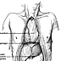 | Figure 1. (click image to zoom) Incision used for multiple organ procurement. The incision used for multiple organ procurement is made from the suprasternal notch to the pubis. The falciform ligament is divided and the pericardium opened.
The traditional technique (which, as noted, is appropriate only in stable donors) involves significant dissection and is particularly helpful in multiple organ procurement, during which organs must be separated according to their blood supply. Minimal dissection is required to prepare the heart for removal. The superior vena cava and the aorta are dissected to allow eventual occlusion of the inflow and outflow tracts. The heart team generally completes its preliminary work in roughly 15 minutes. The abdominal teams then proceed; their specific approach is based on the physiologic status of the donor. In hemodynamically stable donors, many surgeons, depending on their experience, prefer to perform varying amounts of dissection before in situ flushing, especially when multiple organ procurement is planned. Lengthy preliminary dissections should be avoided, particularly in unstable donors: ischemia during long dissections may cause poor graft function or even graft failure. Occasionally, when the donor has previously undergone a sternotomy and the heart is not being procured for transplant, it may be prudent to perform the sternotomy after the abdominal dissection is complete and the distal aorta has been isolated and cannulated. Although this approach provides more limited exposure at first, it helps ensure that the organs will not be lost should the heart be injured during the reopening of the sternum.
The left triangular ligament of the liver is then divided. In the majority (~67%) of cases, the common hepatic artery arises from the celiac axis. Often, there is aberrant hepatic arterial anatomy, including a left branch (accessory or replaced) that generally comes from the left gastric artery (~15% of cases) and traverses the gastrohepatic ligament; a right branch (accessory or replaced) that generally comes from the superior mesenteric artery (SMA) (~10% of cases) and courses behind the portal vein; or both.^{[22]} Identifying anatomic variations early in the procedure helps minimize the risk of accidental injury to vital structures. Once the gastrohepatic ligament is opened, the esophagus (with a nasogastric tube in place) is retracted to the left with a finger and a longitudinal incision made in the diaphragmatic crura between the retrohepatic inferior vena cava (IVC) and the esophagus [see Figure 2]. The supraceliac aorta is exposed at this level in preparation for later cross-clamping. Alternatively, the aorta can be clamped in the left chest (e.g., in a donor with an abdominal aortic aneurysm or severe abdominal aortic atherosclerosis). At this time, varying amounts of dissection can be completed, depending on which organs are to be procured, the surgeon's preference, and, in particular, the stability of the donor.
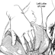 | Figure 2. (click image to zoom) Division of gastrohepatic ligaments. The left triangular and gastrohepatic ligaments are divided so that the left lobe of the liver can be retracted to the right. The diaphragmatic crura are divided between the esophagus and the vena cava to facilitate exposure and encirclement of the aorta at the level of the diaphragm.
During the dissection, the distal abdominal aorta is encircled and the inferior mesenteric artery ligated and divided. Care should be taken in the dissection of the distal aorta to ensure that no accessory renal arteries originate from the proximal common iliac arteries. If such an artery is present or if the distal aorta cannot be cannulated, the distal common iliac artery can be encircled and cannulated. In addition, the inferior mesenteric vein is dissected free and cannulated for a portal flush. Generally, the catheter used for a portal flush is manually directed cephalad into the portal vein itself, unless the pancreas is being procured, in which case the cannula is left within the inferior mesenteric vein.
Once dissection is complete, the donor is systemically heparinized, and after 3 minutes or so, the distal aorta is ligated at the level of the bifurcation and the aortic perfusion cannula inserted and secured in place [see Figure 3]. The abdominal and thoracic teams should coordinate their efforts at this time. Effective circulation is terminated by cross-clamping the aorta at predetermined levels in the chest and in the abdomen [see Figure 4].
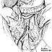 | Figure 3. (click image to zoom) Exposure of distal aorta. The small intestine is reflected, the distal aorta is exposed, and the inferior mesenteric artery is ligated and divided. Catheters are inserted into the inferior mesenteric vein and into the distal aorta.

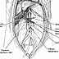 | Figure 4. (click image to zoom) Cross-clamping of aorta. The aorta is cross-clamped at the diaphragmatic level and at the arch level in the chest at the time of rapid infusion.
Cold UW solution is then instilled through the perfusion cannulas, and sterile ice is placed over all of the abdominal organs. With a pH of 7.4 and an osmolarity of 320 mOsm/L, UW solution maintains the organs' cellular integrity; in addition, it contains antibiotics, antioxidants, and heparin [see Table 1]. Cooling the organs to 4° C slows cellular metabolic functions dramatically; however, it does not arrest them completely, which means that a degree of ischemia occurs during cold storage. Once the aorta is cross-clamped, the clock starts, and all efforts are made to minimize cold ischemia times so as to maximize organ function in the recipient.
The various donor organs differ in their ability to tolerate cold ischemia, and general time limits have been established. Kidneys can be preserved for as long as 72 hours; thus, there is sufficient time for tissue typing and matching, and kidneys can be sent to recipients in distant cities. Nonetheless, when a kidney is stored for more than 24 hours, the chances that it will function immediately in the recipient diminish greatly. The pancreas and the liver may be safely preserved for as long as 20 hours; however, every effort should be made to limit the cold ischemia time to less than 12 hours. The intestine may be preserved for as long as 12 hours, but it should be implanted as soon as possible. For the heart and the lungs, time constraints are more rigid: they should be transplanted within 6 hours of removal from the donor. The accepted time limits, though generally correct, should not be considered absolute. For example, whereas organs from younger donors may tolerate ischemic times closer to the limits, organs from older donors typically will not.
Heart and Lung. After infusion of cold UW solution, the cardiac team proceeds first, removing the heart, the lungs, or both as expeditiously as possible while the abdominal organs are covered with ice slush and perfused with the preservation solution. (As noted, the heart tolerates cold ischemia relatively poorly.) The heart is core-cooled with a potassium-rich cardioplegic solution infused via a cannula inserted into the ascending aorta. Blanching of the heart and cardiac arrest from the cardioplegic infusion occur within a few seconds. At the same time, systemic venous inflow is discontinued by bleeding the IVC into the chest. Care must be taken to leave enough suprahepatic IVC for both the liver and the heart [see Figure 5]. (In the event that the IVC within the pericardium is to be cross-clamped by the cardiothoracic team, the infrahepatic IVC must be vented into the lower abdomen to prevent venous hypertension.) The aorta is divided distal to the innominate artery, and the pulmonary artery is divided at its bifurcation. Most cardiac teams require approximately 10 minutes from the onset of cardioplegic infusion to complete the cardiectomy. The abdominal viscera are blanching and cooling while the cardiac team is completing its procurement.
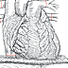 | Figure 5. (click image to zoom) Procurement of heart. The heart is procured by dividing the aorta at the level of the arch and the suprahepatic vena cava with care taken to leave adequate caval length with both the heart and the liver.
The operative technique for lung procurement is generally similar to that for heart procurement [see Figure 6]. After mobilization and isolation of the aorta and the superior vena cava, the trachea is dissected as far above the level of the carina as possible. Prostaglandin E₁ (PGE₁) is given via a catheter in the main pulmonary artery, causing pulmonary vasodilation and thereby optimizing lung perfusion. After infusion of PGE₁ and systemic heparinization, the superior vena cava is ligated and divided. The distal ascending aorta is cross-clamped, the cardioplegic infusion is begun, and topical cold ice slurry is placed on the organs. The lungs are inflated, the endotracheal tube is withdrawn, and the trachea is stapled and divided. The posterior pleurae are incised, and the heart and the double-lung complex are removed from the thoracic cavity, taken to the back table, and separated.
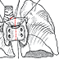 | Figure 6. (click image to zoom) Procurement of heart and lungs. Shown is en bloc procurement of heart and lungs.
Once the thoracic organs have been procured and the abdominal aortic flush completed, the ice is removed from the abdominal cavity--except for some left around the kidneys, which are routinely the last organs to be removed. A patch of diaphragm surrounding the suprahepatic IVC is removed with the liver, with care taken not to cut the esophagus or the aorta on the left side. Subsequent dissection is dictated largely by which organs are to be procured.
Liver, Pancreas, and Intestines. In liver procurement, the diaphragmatic patch is fashioned around the lumen of the suprahepatic IVC. The infrahepatic IVC is divided just above the level of the renal veins, the right adrenal gland is transected, and the liver is excised from any surrounding attachments. The hepatic hilar dissection is then completed. The lesser omentum is incised, and the gastroduodenal artery is identified, ligated, and divided. Care should be taken to ensure that the vessel ligated is truly the gastroduodenal artery and not a low-lying common hepatic artery. The common bile duct is divided close to the duodenum, either before cross-clamping or after the aortic flush, when the organs are cold. The gallbladder is incised and flushed with saline to remove bile from the bile ducts.
Once the gastroduodenal artery has been divided, the portal vein is uncovered posteriorly and followed inferiorly to the junction of the superior mesenteric vein (SMV) and the splenic vein, which are then transected [see Figure 7]. Alternatively, if the pancreas is to be procured, the portal vein is divided approximately 1 to 2 cm above the pancreas so as to leave both the liver and the pancreas with adequate lengths of portal vein. The area posterior to the portal vein must be inspected and divided carefully because it is here that an aberrant right hepatic artery originating from the SMA is most commonly found [see Figure 8]. The celiac axis is traced to its aortic origin and removed with a Carrel patch or a segment of the aorta.
EMBED Word.Picture.8 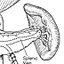 | Figure 7. (click image to zoom) Junction of superior mesenteric vein and splenic vein. The junction of the superior mesenteric vein and the splenic vein is behind the pancreas, as depicted here. Cannulas are shown in the inferior mesenteric vein and the distal aorta.

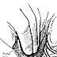 | Figure 8. (click image to zoom) Replaced right hepatic artery. The typical replaced right hepatic artery originates from the first 2 cm of sected portal vein reflected. Also shown is the Carrel patch that will later be created to preserve the celiac axis and the SMA (dashed red line).
Livers that are to be divided (e.g., into right lobe and left lobe or into right trisegment and left lateral segment) for transplantation into two recipients may be split either in situ during procurement or after removal from the donor during a back-table procedure [see Organ Procurement from Living Donors, Living Donor Operation, Liver, below].
The liver is placed in a sterile, empty bag immersed in a basin of ice-slush solution. A cannula may be placed in the SMV or the splenic vein and the liver perfused with additional UW solution. The hepatic artery and the common bile duct are also flushed on the back table. The organ is then packed in the effluent remaining in the bag, placed in an ice-filled cooler, and transported to the recipient hospital, where it is cleaned and prepared for implantation in a formal back-table procedure that takes approximately 30 minutes.
With this technique, removal of a cold and bloodless liver requires 15 to 30 minutes. If the pancreas, the intestines, or both are to be used for transplantation in addition to the liver, it is more efficient to remove the organs en bloc and then separate them on the back table. Simultaneous recovery of a whole pancreas and a whole liver was once considered impossible (because both procedures called for retention of the celiac axis and the portal vein), but safe techniques are now available for dividing the vasculature of these organs. Iliac artery and vein grafts are commonly used as extensions to allow transplantation of multiple abdominal organs from a single donor.
En bloc removal of the liver and the pancreas, with or without the intestines, begins as described earlier (see above), with cannulation of the abdominal aorta. After in situ cooling with UW solution, the diaphragmatic attachments are divided, right medial visceral rotation is performed (Cattell-Braasch exposure), and a Kocher maneuver is carried out. The IVC is then divided above the level of the renal veins. The entire pancreaticosplenic complex can be reflected medially by dividing the lateral attachments [see Figure 9]. The aorta is exposed and opened anteriorly just below the origin of the SMA. The renal orifices are identified within the aorta, and a Carrel patch including the SMA and the celiac axis is fashioned, with care taken not to injure the orifices of the renal arteries [see Figure 9, inset]. With the improved techniques that allow use of the liver and the whole pancreas, the liver retains the majority of the portal vein. Once removed from the donor and placed in an ice-filled basin on the back table, the organs are kept immersed in chilled UW solution. The shorter portal vein segment remaining with the pancreas may be lengthened with an iliac vein graft from the donor. The donor celiac axis and hepatic artery stay with the liver. The splenic artery is divided at its origin from the celiac axis, and the SMA stays with the pancreas. In the case of a replaced right hepatic artery from the SMA, the SMA must be divided distal to the right branch. The pancreatic arterial supply is then reconstructed with a donor iliac artery Y-graft anastomosed to the splenic artery and the SMA [see Figure 10].
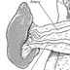 | Figure 9. (click image to zoom) Division of lateral attachments to spleen and pancreas. With the lateral attachments to the spleen and the pancreas divided, the entire pancreaticosplenic complex can be reflected medially. The aorta is thereby exposed and can be incised anteriorly at the level of the SMA so that the orifices of both renal arteries can be identified and preserved (inset).

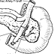 | Figure 10. (click image to zoom) Procurement of pancreas. The pancreas is procured with a segment of duodenum. Shown is the posterior view of the pancreas and duodenum, with the spleen removed. The arterial reconstruction involves using a Y-shaped donor iliac artery graft and anastomosing it to the donor superior mesenteric and splenic arteries. Occasionally a vein graft (not shown) is needed for use as an extension graft for the portal vein.
The organs are then separated along lines determined by their arterial and venous blood supplies. The intestines may be kept in continuity with the liver for use in a composite liver-intestine graft. If this is to be done, the continuity of the duodenum and the head of the pancreas must be kept intact as well. A composite liver-intestine graft requires considerable back-table preparation before implantation. In the case of an isolated small bowel procurement, the root of the small bowel mesentery is dissected at the level of the middle colic vessels, and the SMA and the SMV are identified and isolated. After cold flushing with UW solution, the SMA is divided just distal to the inferior pancreaticoduodenal artery (which supplies the head of the pancreas) and the SMV is divided at a similar level [see Figure 11].
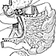 | Figure 11. (click image to zoom) In situ separation of intestinal, pancreatic, and hepatic grafts. Shown is in situ separation of intestinal, pancreatic, and hepatic grafts. The mesenteric dissection is performed at the level of the middle colic vessels, with care taken to preserve the inferior pancreaticoduodenal artery and vein with the pancreatic graft. The aorta is divided just distal to the SMA and just proximal to the renal arteries.
The use of multiple organs from appropriate donors, including split liver grafts, should be encouraged. Care must be taken, however, to protect all of the organs, particularly when arterial hepatic anomalies exist. Because diabetics have the option of insulin administration, whereas patients with hepatic failure have no other options, if an anomaly in the donor precludes successful procurement of both the liver and the pancreas, liver recovery takes priority. Organs recovered from a single donor may end up at multiple recipient institutions; thus, cooperation between surgeons is essential before, during, and after the donor procedure.
Kidneys. After procurement of the liver, the pancreas, or the intestine, the kidneys (protected with ice to this point) are procured from their retroperitoneal positions. The ureters are divided at the level of the pelvic brim, with care taken not to strip the surrounding periureteral tissue. The kidneys are generally removed en bloc, with the lower abdominal aorta and the IVC kept in continuity [see Figure 12]. Once removed, the kidneys are immersed in a sterile bag in an ice-filled basin and are reperfused with cold UW solution, either individually or through the aorta. If the kidneys are to be separated, the left renal vein is transected flush at the point where it enters the IVC. The remaining IVC is kept with the right renal vein, which generally is considerably shorter than the left renal vein. The kidneys are then turned over so that the posterior wall of the aorta is accessible. The paired lumbar arteries arise posteriorly and are a perfect guide for directing the subsequent aortic incision. The posterior wall of the aorta is opened longitudinally in the midline (between the paired lumbars) in such a way as to expose the orifices of the renal arteries [see Figure 13]. The anterior wall of the aorta is then divided longitudinally to separate the kidneys. If continuous perfusion (i.e., pumping) is planned, aortic flaps can be fashioned and used to close the two kidneys, either together or separately, so that cannulas need not be placed directly into the renal arteries. Final preparation of the kidneys for implantation is performed at the recipient hospital on the back table.
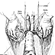 | Figure 12. (click image to zoom) En bloc nephroureterectomies. Shown are en bloc nephroureterectomies being performed from below upward (i.e., cranial to caudal).

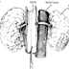 | Figure 13. (click image to zoom) Opening of aorta. The aorta is opened posteriorly between the paired lumbar arteries.
The iliac arteries and veins, as well as the thoracic aorta, the carotid arteries, and the subclavian arteries, may be removed and placed in cold UW solution. Vascular grafts can be lifesaving in the event of an expected or unexpected technical problem in a recipient (e.g., portal vein thrombosis or celiac axis stenosis). These grafts are often invaluable in cases of living donation in which extension grafts are not readily available.

Table 1. Composition of University of Wisconsin (UW) Solution*

Raffinose, 30 mmol/L
Lactobionate, 100 mmol/L
Hydroxyethyl starch, 50 g/L
Sulfate, 5 mmol/L
Phosphate, 25 mmol/L
Allopurinol, 1 mmol/L
Potassium, 125 mmol/L
Sodium, 125 mmol/L
Magnesium, 5 mmol/L
Adenosine, 5 mmol/L
Glutathione, 3 mmol/L
*Penicillin and heparin are added within 2 hours of use.

REFERENCES
- Abu-Elmagd K, Fung J, Bueno J, et al: Logistics and technique for procurement of intestinal, pancreatic, and hepatic grafts from the same donor. Ann Surg 232:680, 2000 [PMID 11066140]
- United Network for Organ Sharing. http://www.unos.org, accessed April 10, 2002
- Tullius SG, Volk H-D, Neuhaus P: Transplantation of organs from marginal donors. Transplantation 72:1341, 2001
- Tenderich G, Koerner MM, Stuettgen B, et al: Extended donor criteria: hemodynamic follow-up of heart transplant recipients receiving a cardiac allograft from donors > or = 60 years of age. Transplantation 66:1109, 1998 [PMID 9808501]
- Emre S, Schwartz ME, Altaca G, et al: Safe use of hepatic allografts from donors older than 70 years. Transplantation 62:62, 1996 [PMID 8693547]
- Kootstra G, Kievit J, Nederstigt A: Organ donors: heartbeating and non-heartbeating. World J Surg 26:181, 2002 [PMID 11865348]
- Nghiem DD, Schlosser JD, Hsia S, et al: En bloc transplantation of infant kidneys: ten-year experience. J Am Coll Surg 186:402, 1998 [PMID 9544953]
- Stratta RJ, Bennett L: Preliminary experience with double kidney transplants from adult cadaveric donors: analysis of United Network for Organ Sharing data. Transplant Proc 29:3375, 1997 [PMID 9414754]
- Miller CM, Gondolesi GE, Florman S, et al: One hundred nine living donor liver transplants in adults and children: a single-center experience. Ann Surg 234:301, 2001 [PMID 11524583]
- Sutherland DE, Goetz FC, Rynasiewicz JJ, et al: Segmental pancreas transplantation from living related and cadaver donors: a clinical experience. Surgery 90:159, 1981 [PMID 7020134]
- Cicalese L, Sileri P, Rastellini C, et al: Living related small bowel transplantation. Graft 4:526, 2001
- Cohen RG, Barr ML, Schenkel FA, et al: Living-related donor lobectomy for bilateral lobar transplantation in patients with cystic fibrosis. Ann Thorac Surgery 57:1423, 1994
- Report of the Ad Hoc Committee of the Harvard Medical School to Examine the Definition of Brain Death: a definition of irreversible coma. JAMA 205:85, 1968
- Report of the Medical Consultants on the Diagnosis of Death to the President's Commission for the Study of Ethical Problems in Medicine and Biomedical and Behavioral Research. Guidelines for the determination of death. JAMA 246:2184, 1981
- "Medicare and Medicaid Programs; Hospital Conditions of Participation; Identification of Potential Organ, Tissue, and Eye Donors and Transplant Hospitals' Provision of Transplant-Related Data, Final Rule." Federal Register 63:33856, 22 June 1998
- Evanisko MJ, Beasley CL, Brigham LE, et al: Readiness of critical care physicians and nurses to handle requests for organ donation. Am J Crit Care 7:4, 1998 [PMID 9429678]
- Ceck JM: Clinical Transplants 1997. UCLA Tissue Typing Laboratory, Los Angeles, 1998
- Kamath PS, Wiesner RH, Malinchoc M, et al: A model to predict survival in patients with end-stage liver disease. Hepatology 33:464, 2001 [PMID 11172350]
- Fishbein TM, Fiel MI, Emre S, et al: Use of livers with microvesicular fat safely expands the donor pool. Transplantation 64:248, 1997
- Shapiro AJM, Lakey JRT, Ryan EA, et al: Islet transplantation in seven patients with type I diabetes mellitus using a glucocorticoid-free immunosuppressive regimen. N Engl J Med 343:230, 2000
- US Department of Health and Human Services, Health Care Financing Administration. Transmittal AB-00-130: Intestinal Transplantation. December 22, 2000
- Emre S, Schwartz ME, Miller CM: The donor operation. Transplantation of the Liver. Busuttil RW, Klintmalm GB, Eds. WB Saunders Co, Philadelphia, 1996, p 392
- Michon L, Hamburger J, Oeconomos N, et al: Une tentative de transplantation renale chez l'homme: aspects medicaux et biologiques. Presse Med 61:1419, 1953
- Schiano T, Kim-Schluger L, Gondolesi G, et al: Adult living donor liver transplantation: the hepatologist's perspective. Hepatology 33:3, 2001 [PMID 11124813]
- Public Law No. 98-507, Title I, 1984. National Organ Transplant Act. (A bill to provide for the establishment of a Task Force in Organ Procurement and Transplantation and an Organ Procurement and Transplantation Registry, and for other purposes.)
- Abecassis M, Adams M, Adams P, et al: Consensus statement on the live organ donor. The Live Organ Donor Consensus Group. JAMA 284:2919, 2000
- Fishbein TM, Emre S, Guy SR, et al: Safe transplantation of blood type A2 livers to blood type O recipients. Transplantation 67:1071, 1999 [PMID 10221497]
- Ben-Haim M, Emre S, Fishbein TM, et al: Critical graft size in adult-to-adult living donor liver transplantation: impact of the recipient's disease. Liver Transpl 11:948, 2001
- Broelsch CE, Whitington PF, Emond JC, et al: Liver transplantation in children from living related donors. Surgical techniques and results. Ann Surg 214:428, 1991
- Tanaka K, Uemoto S, Tokunaga Y, et al: Surgical techniques and innovations in living related liver transplantation. Ann Surg 217:82, 1993 [PMID 8424706]
- Harringer W, Wiebe K, Struber M, et al: Lung transplantation--10 year experience. Eur J Cardiothorac Surg 16:546, 1999 [PMID 10609906]

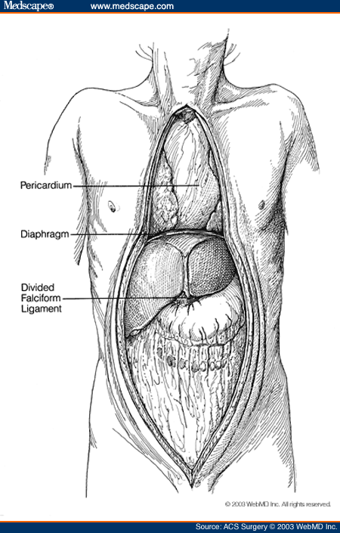
Figure 1. Incision used for multiple organ procurement. The incision used for multiple organ procurement is made from the suprasternal notch to the pubis. The falciform ligament is divided and the pericardium opened.
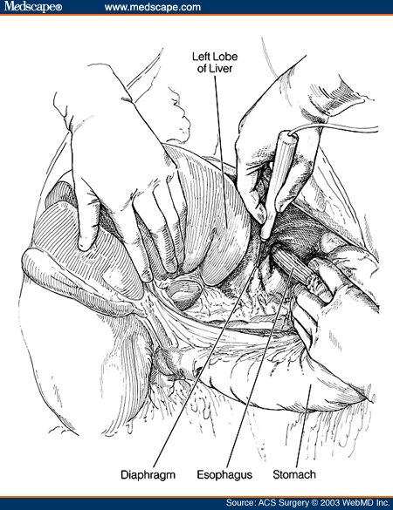
Figure 2. Division of gastrohepatic ligaments. The left triangular and gastrohepatic ligaments are divided so that the left lobe of the liver can be retracted to the right. The diaphragmatic crura are divided between the esophagus and the vena cava to facilitate exposure and encirclement of the aorta at the level of the diaphragm.
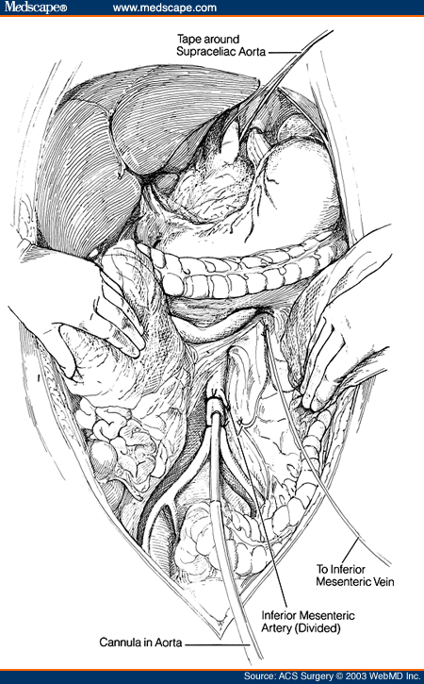
Figure 3. Exposure of distal aorta. The small intestine is reflected, the distal aorta is exposed, and the inferior mesenteric artery is ligated and divided. Catheters are inserted into the inferior mesenteric vein and into the distal aorta.
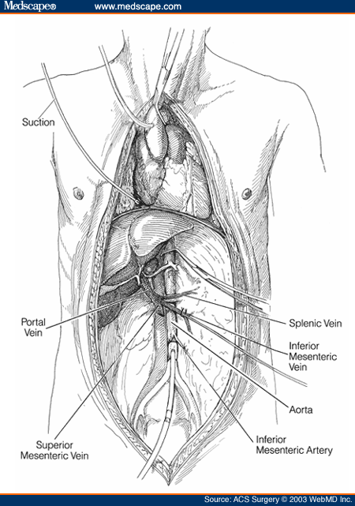
Figure 4. Cross-clamping of aorta. The aorta is cross-clamped at the diaphragmatic level and at the arch level in the chest at the time of rapid infusion.
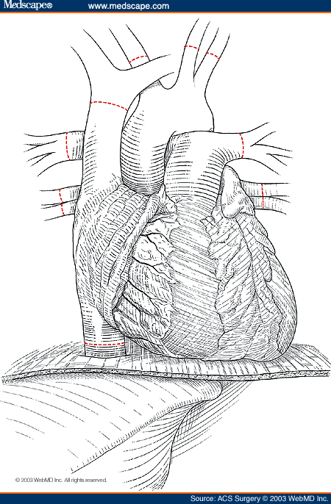
Figure 5. Procurement of heart. The heart is procured by dividing the aorta at the level of the arch and the suprahepatic vena cava with care taken to leave adequate caval length with both the heart and the liver.
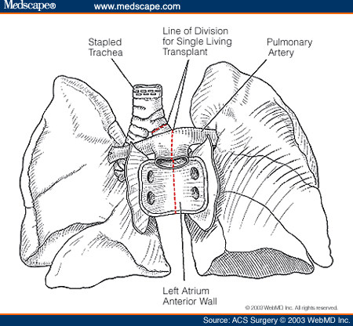
Figure 6. Procurement of heart and lungs. Shown is en bloc procurement of heart and lungs.
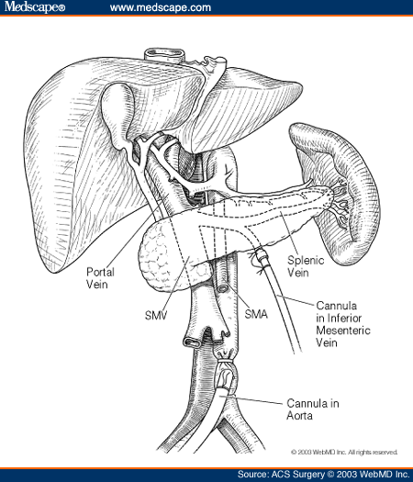
Figure 7. Junction of superior mesenteric vein and splenic vein. The junction of the superior mesenteric vein and the splenic vein is behind the pancreas, as depicted here. Cannulas are shown in the inferior mesenteric vein and the distal aorta.
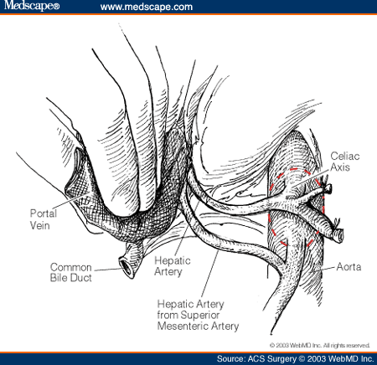
Figure 8. Replaced right hepatic artery. The typical replaced right hepatic artery originates from the first 2 cm of sected portal vein reflected. Also shown is the Carrel patch that will later be created to preserve the celiac axis and the SMA (dashed red line).
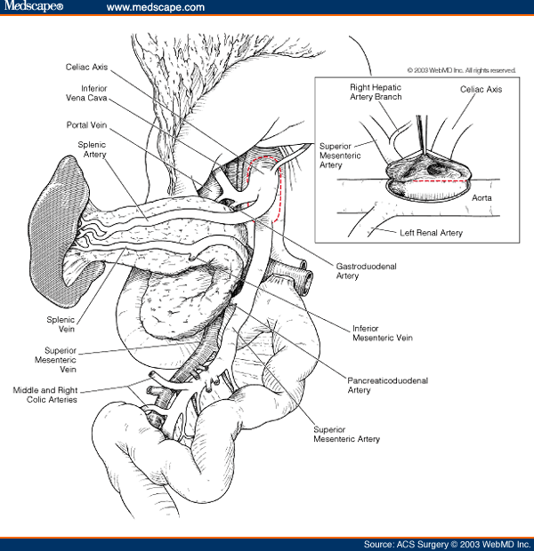
Figure 9. Division of lateral attachments to spleen and pancreas. With the lateral attachments to the spleen and the pancreas divided, the entire pancreaticosplenic complex can be reflected medially. The aorta is thereby exposed and can be incised anteriorly at the level of the SMA so that the orifices of both renal arteries can be identified and preserved (inset).
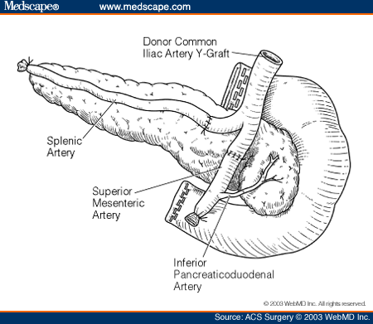
Figure 10. Procurement of pancreas. The pancreas is procured with a segment of duodenum. Shown is the posterior view of the pancreas and duodenum, with the spleen removed. The arterial reconstruction involves using a Y-shaped donor iliac artery graft and anastomosing it to the donor superior mesenteric and splenic arteries. Occasionally a vein graft (not shown) is needed for use as an extension graft for the portal vein.
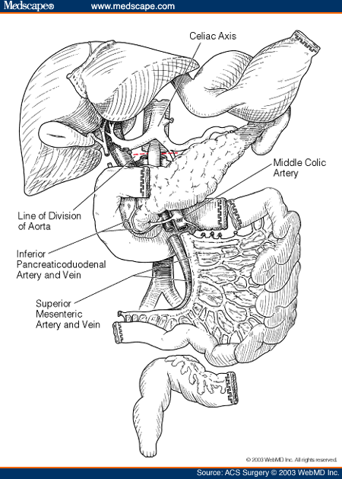
Figure 11. In situ separation of intestinal, pancreatic, and hepatic grafts. Shown is in situ separation of intestinal, pancreatic, and hepatic grafts. The mesenteric dissection is performed at the level of the middle colic vessels, with care taken to preserve the inferior pancreaticoduodenal artery and vein with the pancreatic graft. The aorta is divided just distal to the SMA and just proximal to the renal arteries.
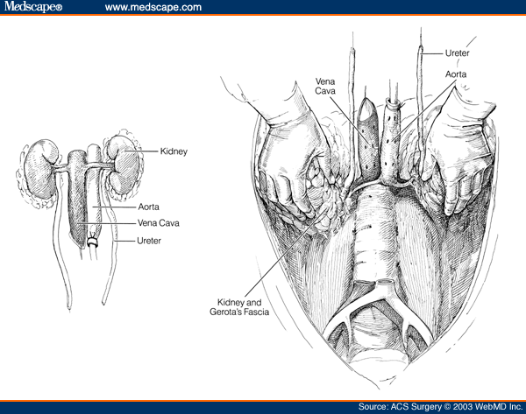
Figure 12. En bloc nephroureterectomies. Shown are en bloc nephroureterectomies being performed from below upward (i.e., cranial to caudal).
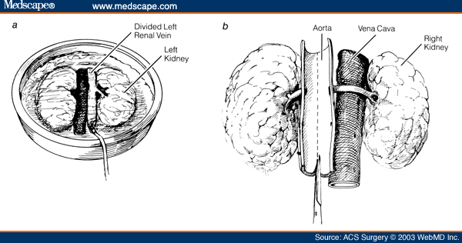
Figure 13. Opening of aorta. The aorta is opened posteriorly between the paired lumbar arteries.
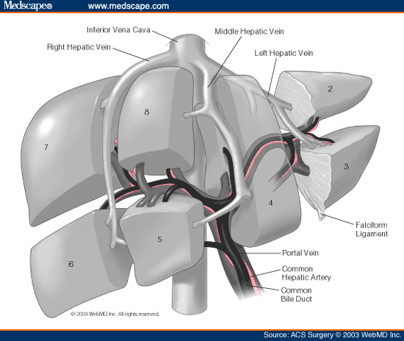
Figure 14. Segmental liver anatomy. Depicted is segmental liver anatomy as originally described by Couinaud. The right lobe consists of segments 5 through 8, the left lobe of segments 2 through 4, and the left lateral segment of segments 2 and 3.
ORGANIGRAMMA EQUIPE CHIRURGICA PRELIEVO ORGANI

FEGATO INTERO
OPERATORE: CHIRURGO RESPONSABILE (Dr. M. Casaccia, Dr. F. Panaro, Dr. G. Bottino, Dr. N. Morelli)
AIUTO: MEDICO SPECIALIZZANDO V-VI ANNO SPECIALIZZAZIONE (Dr. F. Ravazzoni, Dr. A. Savelli)
ASSISTENTE: MEDICO SPECIALIZZANDO II-III-IV

